E-Project

“CARE Hospitality System”

|  |  |
| --- | --- |
| Student Name | Student ID |
| Danish Asif | 1425944 |
| Anwar khan | 1423510 |

Faculty Name: Miss Bakhtawar Siraj

Co-ordinator Name: Miss Hafsa Qadir

Batch Code: 2210F3

**Problem Statement**

We all need to visit doctors some time or the other. Sometimes it is an emergency situation, whereas most of the other time it is a planned checkup/visit. But in both the cases we have to visit the doctor to take an appointment or wait in long queues.

CARE Group is into medical services for long time and looking at the current medical scene have decided to come up with a WEBSITE, which will host the medical services available in different cities.

Individuals will be able to search for specialist doctors in their surroundings and even book online appointments.

Web site should also record the complete information regarding the Doctors and Patients.

**Customer Specifications:**

Website will host information about common Diseases, Preventions and Cures. It will also display the latest medical news and information on inventions in Medical Science.

The website will have three users/roles:

1. Admin
2. Doctor
3. User

The Administrator should be able to do the following:

1. Add Cities to the master database.
2. Add Doctors to the Master database.
3. Modify Doctor Details.
4. Modify Patient Details.
5. Delete Cities
6. Delete Doctors
7. Delete Patients
8. Create/Manage Users/Logins
9. Manage information/details on the WEBSITE

The Doctor should be able to do the following:

1. Login into the system with his USER/PASSWORD
2. View his/her profile details
3. Add details to his/her profile
4. Modify his/her profile
5. View Appointments
6. Update his availability for DAY/WEEK/MONTH

The Patient should be able to do the following:

1. Register [USERID should be unique].
2. Search Doctor based on location, Specialist
3. Book Appointment [Check Availability]

Note: Name, Address, Phone Numbers, Email-ids should be mandatory to be provided.

**Work Done**

1. Database
2. Register
3. Login/Signup

**Work In Progress**

1. Admin Panel
2. Appointment

3.User Panel

4.Doctor Panel

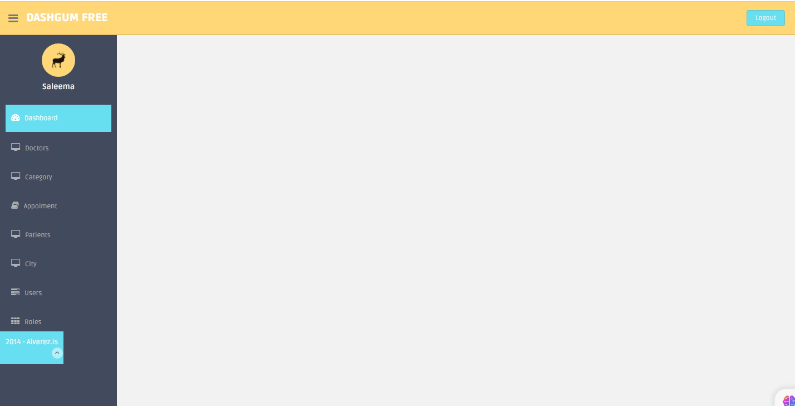

Doctor Panel:

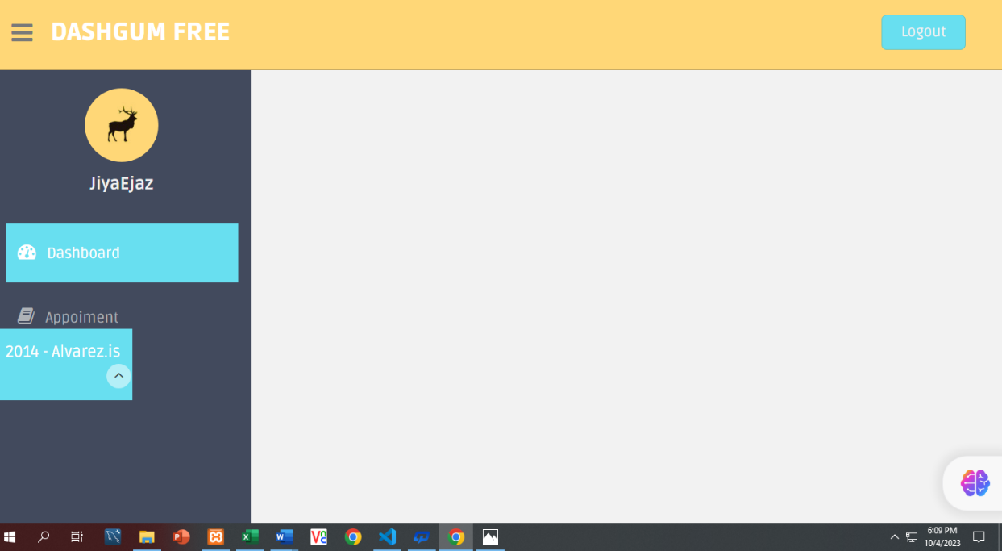

User Login:

User Page:

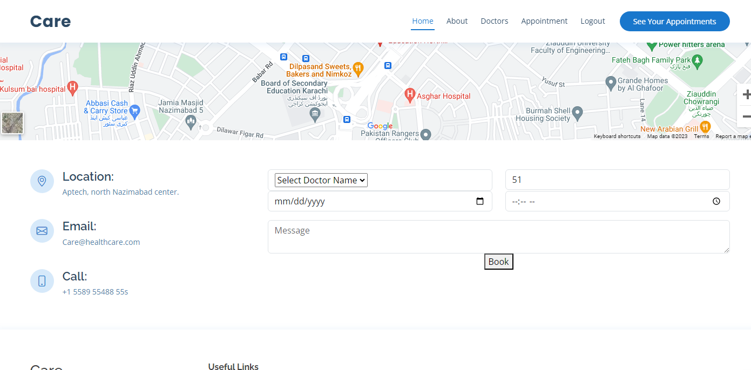

See Appointment:

